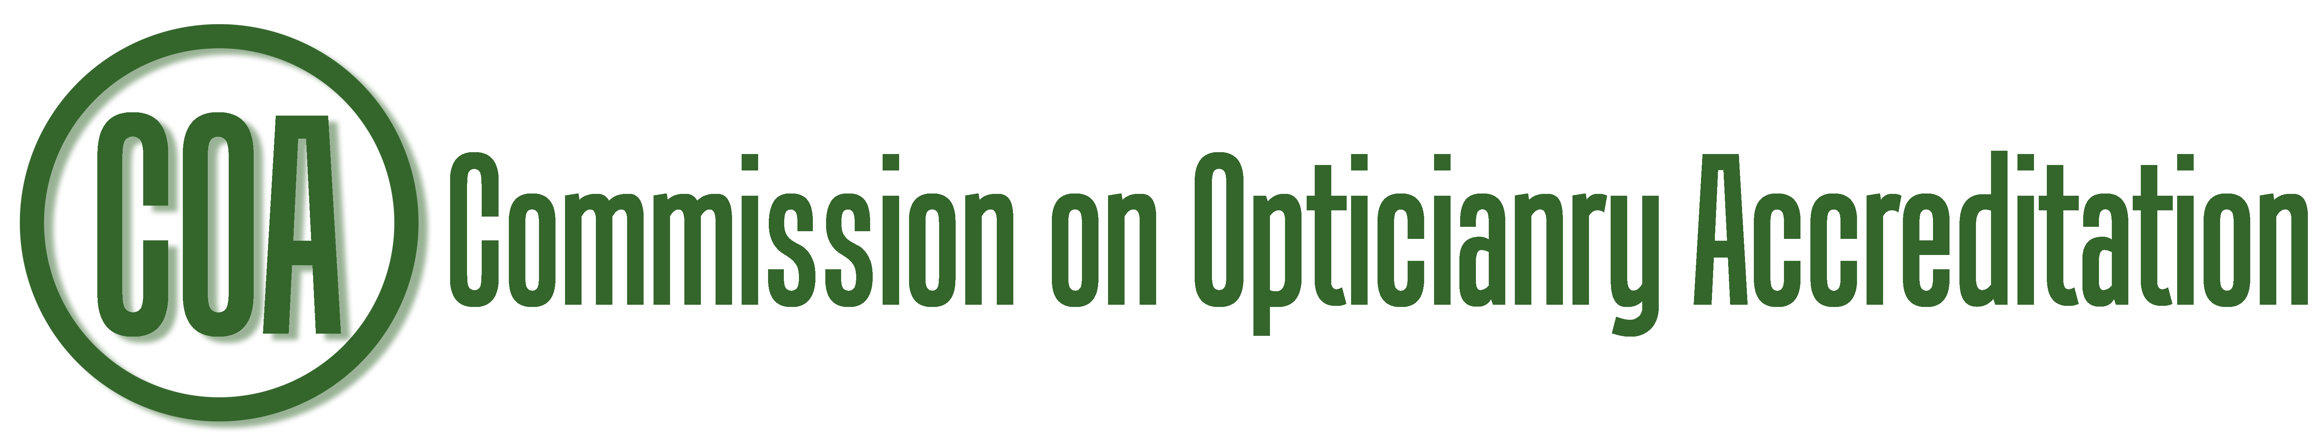
Jayne H. Weinberger, EdD
229 East 85th Street #194
New York, NY, 10028
e-mail: director@COAccreditation.com
voice: 315-742-8066

APPLICATION FOR ACCREDITATION
or RE-ACCREDITATION
OPHTHALMIC DISPENSING PROGRAM

- Name of Institution: ______________________________________________________
Address: ______________________________________________________
- Title of Program: ______________________________________________________
- Institutional regional/state accreditation(s) agency and expiration date of accreditation:
__________________________________________________ Exp. date: ___________
__________________________________________________ Exp. date: ___________
Programmatic Accreditation, if applicable:
__________________________________________________ Exp. date: ___________
- Program Director's Name: __________________________________________________
Official Title: __________________________________________________
Phone Number: __________________ e-mail address: ___________________________
- Division Dean's Name: __________________________________________________
Official Title: __________________________________________________
Phone Number: __________________ e-mail address: ___________________________
- Chief Executive Officer's Name: _____________________________________________
Official Title: _____________________________________________

If a new program, please answer 7 and 8:
- Year first ophthalmic dispensing class graduated: _______________
- Year ophthalmic dispensing program began operation: ___________

- Specify degree awarded upon completion of program to be accredited by COA:
_____________________________________________________________________
- If program uses another institution for any part of its program, on a separate page please indicate the name of the institution, program responsibility at institution, and address and phone number of contact person at that institution.
- For initial accreditation the on-site visits are typically three days, Monday – Wednesday. For reaffirmation of accreditation for currently accredited programs the on-site visits are typically two days, Monday – Tuesday. Please indicate below three dates that would work for your program for the on-site visit. If possible the dates will be chosen from the dates requested, based on the availability of the visiting team members.
  - Date 1 _______________________________
  - Date 2 _______________________________
  - Date 3 _______________________________
Signature: ______________________________________ Date: ________________
Program Director

Signature: ______________________________________ Date: ________________
Dean or CEO

This application should be returned electronically to: Jayne Weinberger, Director of Accreditation, director@COAccreditation.com

Program seeking initial accreditation must remit $500.00 application fee, due 4 weeks before the on-site visit.
Programs seeking reaffirmation of current accreditation must remit $250 fee, due 4 weeks before the on-site visit.
This application will be kept on file for one year. The fee will be applicable for one year.

Office use only
Date received in COA office: _______________________________

On-site scheduled for: _______________________________

Date fee and self-study due: _______________________________

Fee and self-study received: ____________________________

